**The Two Rival Versions of TBLT of Peter Robinson and Peter Skehan.**

Here I offer a brief summary of Robinson’s and Skehan’s approaches to TBLT and a few comments.

We begin with the three (now four) related constructs that are used by SLA researchers interested in estimating the spoken proficiency of learners, viz.: Complexity, Accuracy and Fluency.

**CAF & CALF**

We should note that structural complexity and lexical complexity are now treated separately by Skehan and many others hence CALF. The generally recognized ways of operationalizing these constructs are as follows:

Complexity: measured in terms of subordination, in the form of the total number of clauses divided by the number of Analysis-of-speech units. An AS-unit is "a single speaker's utterance consisting of an independent clause or subclausal unit, together with any subordinate clause(s) associated with it" (Foster et al. 2000, p. 365). Lexical sophistication is usually measured with the “Beyond 2000” measure, derived from the lexical frequency profile proposed by Laufer and Nation (1995). It involves examining lexical use in terms of frequency bands.

Accuracy: measured through the percentage of error-free clauses

Fluency: Skehan (2009) calls it “the capacity to produce speech at normal rate and without interruption”, so the measure is of the frequency of pauses.

It’s important to note that different researchers have used a range of measurements when investigating these three aspects of the performance of people learning English as an L2, and that CAF measurements are also used to evaluate written proficiency, and overall proficiency.

We will now look at how Robinson suggests manipulating tasks in such a way that the learners’ proficiency can improve, using CAF as a judge of performance. The emphasis will be on oral performance.

**Robinson's Cognition Hypothesis** (2011) is a pedagogic claim, to the effect that increasing the cognitive demands of tasks along certain dimensions will lead to different kinds of production and learning. He holds a multi-resources view of attention, which entails the claim that a learner can expand those resources to meet increasing task demands. (In contrast, as we’ll see, Skehan’s LAC (Limited Attention Capacity) approach claims that a learner’s attentional resources are limited, which has important implications).

Robinson (2001: 29) defines task complexity as “the result of attentional, memory, reasoning, and other information processing demands imposed by the structure of the task on the language learner”. He divides task complexity into resource-directing and resource-dispersing dimensions. The resource-directing dimension refers to cognitive, conceptual requirements, including

* few/many elements
* here-and-now
* there-and-then
* +/-reasoning demands. T

The resource-dispersing dimension refers to procedural and behavioural requirements, including

* +/-planning
* task structure
* single/dual task
* +/-prior knowledge.

He argues that increasing task complexity in the resource-directing dimension leads to development of the learner’s interlanguage, and thus to higher accuracy and complexity of L2 performance, but that fluency is adversely affected. On the other hand, increasing task complexity in the resource-dispersing dimension gives the learner opportunities to practice within their existing L2 knowledge, and can thus be expected to lead to more fluency.

As we can see from Fig. 1 below, Robinson’s TBLT framework consists of three parts. Factors affecting task conditions and task difficulty are seen as “Methodological influences”, secondary to the cognitive factors of task complexity.

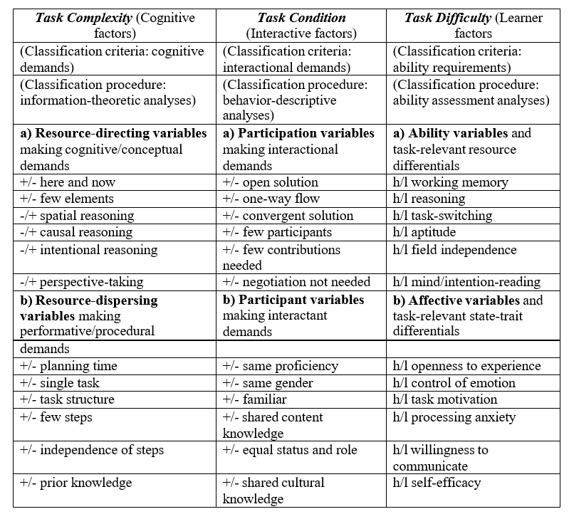

Figure 1. The Triadic Componential Framework for task classification—categories, criteria, analytic procedures, and design characteristics (from Robinson, 2007).

The fundamental pedagogic claim of the Cognition Hypothesis is that task sequencing should be done by designing and having learners perform tasks simple on all the relevant parameters of task demands first, and then gradually increasing their cognitive complexity on subsequent versions. Such sequences allow for cumulative learning, since each task version differs in only small respects from the previous one, but also introduces an incremental increase in the conceptual and communicative challenge of the task which prompts learners to adjust and expand their interlanguage resources to meet it, thereby creating the conditions for L2 development. Robinson elaborates on this with his SSARC (Simplify, Stabilize/ Automatize/ Restructure, Complexify) sequence.

**The 3-step SSARC Sequence**

Step 1: Tasks are simple on all dimensions are performed (e.g. + planning, − intentional reasoning). Task performance thus draws on the simple, stable (SS) ‘attractor state’ of current interlanguage.

Step 2: Increase the complexity on resource-dispersing dimensions (e.g., less or no planning time; and less or no intentional reasoning). This, claims Robinson, promotes speedier access to, and so automatization (A) of, the current interlanguage system.

Step 3: Increase the complexity on both resource-dispersing and resource directing dimensions (e.g., − planning, + intentional reasoning). This, claims Robinson, promotes restructuring (R) of the current interlanguage system, and introduces maximum complexity (C), which destabilises the current interlanguage system.

Let’s turn now to Skehan’s approach.

**Skehan’s Limited Attentional Capacity (LAC) approach** starts from the claim that, Robinson notwithstanding, a human’s attentional resources are limited (and their working memory is severely limited). Given this limitation on attentional resources, when learners are performing tasks, there is competition between complexity, accuracy, and fluency for attentional resources, such that one is prioritized at the expense of the others. Since meaning normally takes priority when students perform communicative, meaning-based tasks, fluency is usually given priority, and thus complexity and accuracy suffer. Furthermore, even when there is attention available for form, there is a further tension between attention directed to complexity and attention directed to accuracy. In support of Skehan’s approach, Skehan & Foster (2001) cite a study by VanPatten (1990) which showed that when performing a task, if learners were asked to pay attention to language forms, the language content suffered, and that when they were allowed to allocate attention freely, they prioritised content over form. The implication is that tasks which are cognitively demanding in their content are likely to draw attentional resources away from language forms, encouraging learners to avoid more attention-demanding structures in favour of simpler language for which they have already developed automatic processing (the ‘safety first approach'). Conversely, very cognitively demanding content might result in learners paying insufficient attention to language forms which still require controlled processing and which are therefore likely to be poorly done (the ‘accuracy last' approach).

If we allow that learners can be seen to be developing their interlanguages in terms of the increased complexity, accuracy and fluency of their production, Skehan suggests that CAF can be used to capture how new language is developed and how, subsequently, greater control is achieved over this new language, and this leads him to contest Robinson’s SSARC sequencing model. Skehan insists that we begin with complexity. At any point in IL development, we may notice the use of new cutting edge and possibly risky language, and this, Skehan suggests, foreshadows growth in the interlanguage system. Next comes accuracy, which represents a striving for control and error avoidance, possibly by the avoidance of cutting-edge language, and by avoiding fluency to enable more time to be used to achieve higher accuracy. Finally, fluency represents a focus on meaning, automatisation, lexicalization and a push for real-time processing.

Skehan is suggesting that the CAF categories can be used to represent an acquisitional sequence. Tasks which promote greater complexity push for new language, while tasks which promote accuracy or fluency support control of an existing interlanguage level. In this view, first there is what Skehan calls destabilization, and then there is a concern for accuracy (eliminating errors) and then for achieving fluency. If we assume that the goal in language instruction is improvement in all the three areas (with perhaps the dynamic of restructuring-led change producing greater complexity, followed by greater control and accuracy, with fluency and lexicalised communication achieved last), then it is important in designing instruction sequences (a) to monitor profiles of performance, and (b) to be able to adjust instruction to foster balance in IL and performance. To achieve this, knowledge of task factors which promote development in the different areas is essential, as is knowledge of how different conditions of task implementation similarly have selective effects.

So Skehan sees the central challenge for TBLT as discovering how task characteristics and task conditions can be manipulated to produce performance which maximises complexity, accuracy, and fluency. To do this, the first step is to find a way of assessing the cognitive difficulty of different tasks. While some tasks are pretty obviously less cognitively taxing: “talking about how many people there are in your family could be confidently described as less taxing for most learners than discussing euthanasia, and speculating on what is happening in some bizarre photograph is probably a lot more taxing for most learners than describing a story told explicitly in a cartoon strip” (Skehan & Foster, 2001), there are other less obvious dimensions to tasks that need to be taken into account. Skehan (1996) proposes an analysis of task complexity in three principal areas: language, cognition and performance conditions.

1. Code complexity: linguistic complexity, and lexical load and variety.
2. Cognitive complexity: can be divided into a) cognitive familiarity (familiarity of topic; familiarity of discourse genre; familiarity of task) and b) cognitive processing (information organization; amount of ‘computation'; clarity of information given; sufficiency of information given
3. Communicative stress: time pressure; scale; number of participants; length of texts used; modality stakes; opportunity for control.

In the first area, tasks which require more advanced structures, or which require the use of wider repertoires of structures, or greater densities of advanced structures, such as complex tenses or subordination or embeddings, are likely to be more complex. The same goes for lexical level or repertoire or density.

The second area concerns the manipulation of the cognitive complexity of the task. For example, the on-line processing demands of solving a riddle or a jig- saw whodunnit are likely to consume considerable attention while the task is being done, whereas the processing demands of recounting a simple story are likely to be far less. Then there is the inherent structure of the task. An account of a journey, with a clear beginning, middle and end, could be seen as easier to process than an account of a complex situation in which several narrative strands have to be cross-referenced. Also important is the degree to which the task participants already possess the knowledge that will be needed to transact the task, or the extent to which they must absorb and use entirely new information. For example, does the task require the participants to talk about themselves and their own lives, or does it require them to express views on imaginary people and situations which they have only just been presented with. In this regard, the task type is important also: have the participants ever done a similar task before (or even the same task before) so that they are already aware of what is expected of them and don't need to waste attentional resources on figuring this out? Finally, have all the participants been given all the information they require, or are crucial parts of it missing or hidden?

The third area, performance conditions, is concerned with a task's communicative stress and includes three potential sources of stress that could affect performance. There could be pressure on getting a task finished within an allotted time, especially if that allotted time is very short; the task could include listening, reading, writing or speaking, or any combination of the four, thus demanding real-time or slow- time processing, or both; the task may include several participants, all of whom have to be kept involved because they have information the others lack; the task may be viewed as a light-hearted affair at the end of an exhausting class, or as a pre-exam classroom activity in which target language accuracy is very important; the task may or may not allow the participants any scope to control or change its implementation.

From an information-processing point of view it is possible that all of these factors, embracing as they do the linguistic code, the content and the conditions, have some bearing on how a learner's attention during a task is likely to be shared out and how performance is likely to be affected. What is needed then is empirical research that will explore factors such as these and determine what effect, if any, they actually have. Through a series of studies, Skehan, often with Foster) established that different task characteristics and different task conditions exert systematic influences on performance. Various studies used three different types of task:

1. Personal: a personal information exchange task where one student tells another student how to get to their home to turn off a gas oven which had been left on.
2. Narrative: subjects had to construct a story based on a sequence of pictures.
3. Decision making task: subjects had to role play a judge and decide on appropriate punishments for wrong doers.

Changes were made to these tasks in follow up studies in order to further explore the implications, but let’s stick to basics.

**Task Characteristics**

In terms of task characteristics, the results of a number of studies indicated that

* the personal and decision-making tasks produced higher Accuracy than the narrative task.
* The personal task produced less complexity and higher accuracy than the other two.
* A clearly structured task promotes accuracy and fluency.
* Tasks based on familiar or concrete information lead to greater accuracy.
* Fluency, and dialogic tasks lead to greater accuracy and complexity, while monologic tasks generally produce the reverse results.

Interesting in themselves, these conclusions support Skehan’s argument that accuracy and complexity should be separated when examining the effects of task characteristics.

**Task Conditions**

In terms of task conditions, Skehan and his collaborators looked at the effects of pre-planning and the conclusions are:

* pre-task planning consistently produces greater complexity and fluency
* pre-task planning sometimes produces more accurate language
* pre-task planning is more effectively done when led by the teacher, and least effectively done in a group of learners

These conclusions about task conditions lead us to a consideration of Skehan’s view of how tasks should be implemented.

**Methodology**

Skehan’s view of how tasks should be implemented are summarized in Table 2 (Skehan, 1996).

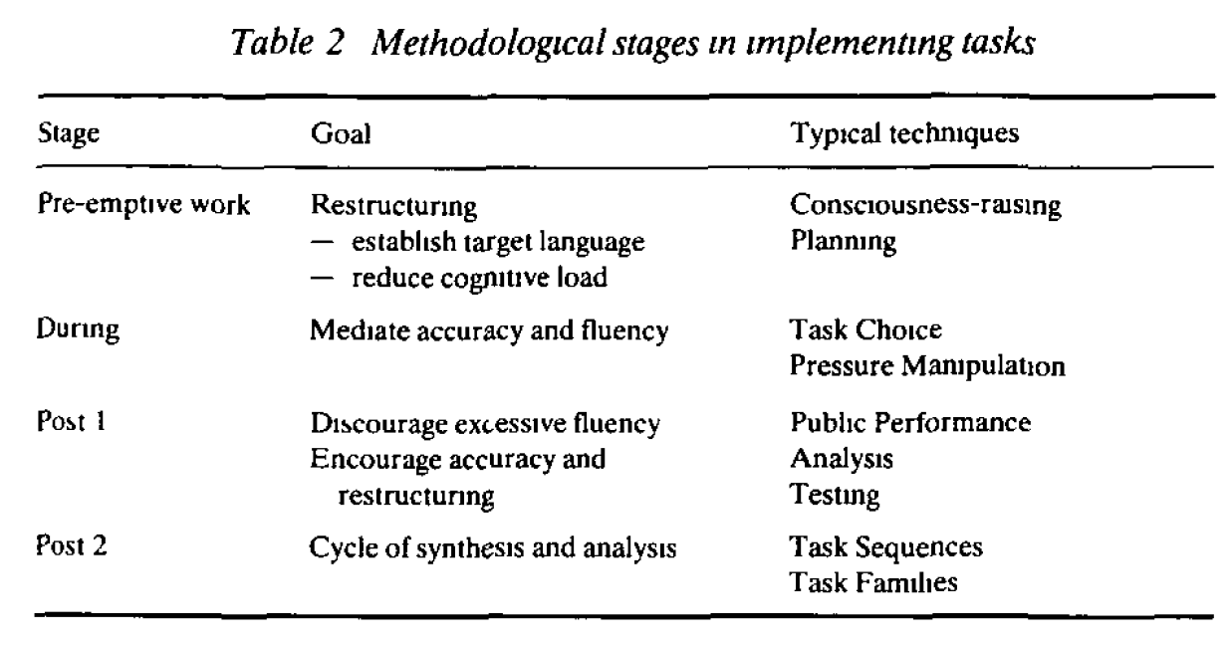

Stage 1: The general purpose of the pre-emptive, or pre-task activities is to encourage restructuring of the students’ interlanguages, in other words, to incorporate new elements or re-arrange existing elements. These activities aim to bring to the learner’s attention, i.e. to make salient, language which will be relevant to task performance. They can also aim to ease the processing load that learners face when actually doing a task, releasing more attention for the actual language that is used, so that more complex language can be attempted and greater accuracy can be achieved.

Stage 2: The main factor affecting performance during the task is the choice of the task itself, Tasks should not be so difficult that excessive mental processing is required simply to communicate any sort of meaning. Nor should tasks be so easy that learners are bored, and do not engage seriously with the task requirements, with the result that no gain is made in terms of stretching interlanguage or developing greater automaticity.

Stage 3: Then there are the post-task activities. Skehan argues that learners’ knowledge of what is to come later can influence how they approach attention-management during an actual task. While a task is being done, the teacher needs to withdraw and allow natural language acquisitional processes to operate. But the danger is that communication goals will be so predominant that lexicalized communication strategies will become so important that the capacity to change and restructure, to take syntactic risks, and to try to be more accurate, will not come into focus as serious goals. Post- task activities can change the way in which learners direct their attention during the task by reminding learners that fluency is not the only goal.

In ‘Post 1’, Skehan suggests three general post-task activities: public performance, analysis, and tests. In public performance, learners are asked to repeat their performance, publicly, in front of an audience – the rest of the class, the teacher, or a video camera. Skehan, following Willis (2009), suggests that the knowledge while the task is being done that a task may have to be re-done publicly will cause learners to allocate attention to the goals of restructuring and accuracy. Analysis can involve the teacher or the students reviewing the performance, and tests can be whatever the teacher thinks is appropriate. In Post 2, the teacher decides what follow up work is required.

**The Levelt Model**

It’s noticeable that Skehan’s research was for a long time “bottom-up”. He didn’t start with a big hypothesis and then use studies to test it. Rather, in his studies, he selects a few tasks and then tweaks them, concentrating on this variable or that. He finds that variable X affects outcome Y and then does further studies to check and slowly extend his investigations. Only much later (Skehan, 2009) did Skehan introduces Levelt’s model of speech production (Levelt, 1989) to provide an explanatory theory to support his work. Here’s Levelt’s model:

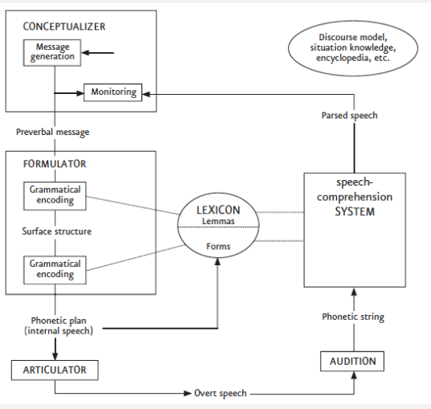

:

The Conceptualizer initiates the speech production process by generating the message. The Formulator then assembles the “surface structure” of the message and prepares it for phonetic implementation. The Articulator then actually “speaks” and sends the message to the interlocutor. Skehan reminds us that Levelt’s model assumes an L1 speaker, and assumes that the Conceptualizer and the Formulator engage in parallel processing of the message. Crucially, Skehan says, the model ceases to function in the same way for L2 learners, since smooth simultaneous processing is hindered, precisely, by the cognitive demands that speaking in an L2 involves. Skehan (2009) offers this Table:

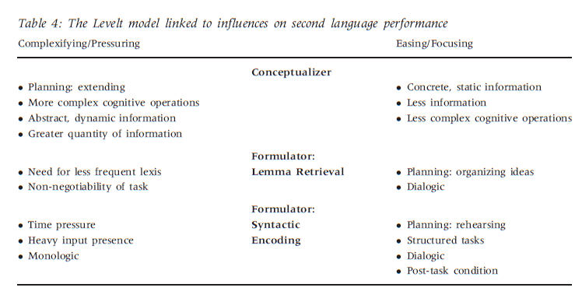

On the left are influences which add to the difficulty of a task. Those that complexify the performance are in the first group, at the Conceptualizer stage. The speaker develops a message which is more demanding of cognitive resources, and which requires more active working memory use during speech production. Next are influences which are relevant at the Formulator stage, which put pressure on performance. At the lemma retrieval stage, the need to use less frequent lexis and the non-negotiability of the task both create pressure because they force the learner to “wrestle with the problems that come from more effortful and slower access to the information stored in lemmas”. At the syntactic stage of Formulation, the speaker is faced with online pressures, particularly the time pressure under which speaking has to take place, and the amount of input the speaker gets preparatory to (or even during) speaking.

On the right-hand side of the Table are influences which either ease the task or alternatively focus attention in a particular area. These are often the reverse of some of the features shown on the left-hand side; for example, while planning on the left is seen as adding to complexity, planning on the right refers to pre-planning, which can ease pressure. For reasons of space, I won’t go through the rest of Skehan’s account of the easing/ focusing influences. Instead, let me quote from a blog post by Ruthie Iida, who, having discussed the Levelt model, says this:

“And then Skehan offers practical advice. Here’s what can be done when learners’ conceptualizers are under strain, and when their Formulators cease to formulate smoothly. To begin with, the goal is to decrease pressure on both the Conceptualizer (the Information Guy, whose job is to prime the Formulator so that lexis can be more easily retrieved) and the Formulator (the Planner, who accesses the words and generates the message to be articulated). A clever teacher can arrange and adjust learners’ tasks to ease the burdens of both. To placate the Conceptualizer, then, design tasks with concrete, static information--less is more. And keep it simple, so the learner feels grounded rather than overwhelmed. For the Formulator, Skehan suggests that teachers do the basic planning so that students can limit their focus to the task itself. Dialogs, he says, are less overwhelming than monologues. With these two factors addressed, Skehan proposes that the Formulator will be able to access difficult lexis more efficiently. Lastly, the Formulator is concerned with syntax–which means grammar–which refers to the Accuracy component of the troubled CAF trio (or the quarrelling quartet if you include Lexis). Here the task-based solution would be rehearsals. And tight structure. Lastly, more dialogues and a post-task activity will allow students to polish what they have learned in the task, thus improving their accuracy”.

**Discussion**

Since Mike Long’s version of TBLT follows Robinson’s line throughout, examining the differences between Skehan’s and Robinson’s approach will tell us about Long’s. So, what are the differences? Well, perhaps most fundamentally, Skehan doesn’t use a needs analysis, and that’s because he doubts not just the feasibility of such a demanding procedure, but also the principle of such a highly-prescriptive syllabus. Here’s a bit from Ellis, Skehan, Li, Shintani, & Lambert (2019) which explains:

“One key distinction that Prabhu (1987) makes is between syllabuses which are intended to function as operational constructs in the curriculum and those that are intended to function as illuminative constructs. When a syllabus is designed to function as an operational construct in the L2 curriculum, the aim is to provide course content as a resource for teachers to construct their lesson plans and reach curricular goals with different learners in the varying classroom contexts in which they teach. This type of syllabus has low internal structure and leaves methodological and implementational issues to be determined by teachers based on their experience of what works at the local level and the problems that different learners face in the classroom. In short, the syllabus specifies only what will be taught, not how it will be taught. The content of syllabus is fixed, but how the teacher uses this content is flexible. By contrast, when a syllabus is designed to function as an illuminative construct in the L2 curriculum, the aim is accountability for both what will be taught and for what will be learned as a result. The focus at the planning stage is on ensuring accurate prediction so steps are taken to bring what is taught and what is learned into careful alignment. In achieving this end, the line between syllabus and methodology naturally blurs, and the syllabus takes on a much broader role within the curriculum.”

Mike Long’s “illuminative” syllabus would be undesirable, even if it were possible, because “it limits what teachers and learners bring to the learning process in terms of the intuitive decisions and adjustments that they make in optimizing learners’ mastery of syllabus content”. Long (2015) spends some time (Chpt 11, Section 4) discussing to what extent task-based abilities measured in the performance of one task can be used to predict performance on a “similar” task. How transferable are task-based abilities? But Skehan asks the far more fundamental question: “Do we want to teach people how to use English just to do certain tasks in English, such as those required by a hotel receptionist working in Spain or a journalist working in Japan?” Is it not better to design a set of tasks that allows students to use the L2 in such a way that they gain a certain level of communicative competence and that allows teachers (in consultation with a particular cohort of students) to make “intuitive decisions and adjustments” to a less clearly-specified syllabus? I’ll return to this.

At a more practical level, Skehan adopts a three-phase (pre-task -> task -> post-task) framework, very similar to that proposed by Jane and David Willis (e.g. Willis, J. 1996). In the Willis framework, the first phase involves familiarising students with the task topic, explaining what the task involves and its expected outcomes. The second phase comprises three components: task, planning, and report. In the task stage, learners perform the task in small groups; in the second stage learners in each group prepare to report on their discussion, and in the final report stage, learners report to the class about the task they have performed. The rationale is that in the first stage, students will focus on meaning and on getting the task done, whereas in the report stage, aided by the planning time, students will pay more attention to form. In the post-task phase, the teacher gives feedback on aspects of grammar, vocabulary, pronunciation, lexical chunks, etc., that have arisen during the second phase, and leads appropriate activities.

As we saw above, in the section on Skehan’s Methodology, Skehan puts the “public performance” part in the first part of the post-task phase, and includes follow-up tasks as the second stage in the post-task phase. More importantly, perhaps, Skehan takes much more interest in the type of tasks that are used, as seen above. It’s important to note that both Willis and Skehan are against doing any explicit teaching of formal aspects of the language, or of adopting what Skehan calls a ‘structure trapping' approach to tasks, where the task attempts to get students to use a certain structure. Both see this as impractical and note how very adept learners are at avoiding the chosen structure a teacher or task designer has built the task around (Long, of course, sees it as quite simply a mistake). The role of the teacher is not to push learners towards using particular structures but to help them notice what language is required to do a particular task, and then provide help with this where necessary. Skehan and Foster (2001) note that “the stages of planning, and reflection require a focus on form thereby combating any tendency on the part of the learner just ‘to get the job done'”.

In contrast, Long, following Robinson, sees the sequencing of pedagogic tasks from less to more cognitively demanding as the guiding principle of the syllabus. Long doesn’t rule out a pre-task or post-task phase, but neither does he give them much importance. It’s important that students are clear about what they have to do, and there might be some value in post-task teacher feedback, although Long is wary of this “degenerating” into a focus on forms session. It’s the careful sequencing of the pedagogic tasks, which involves input from a sequence of carefully-produced, elaborated and enhanced multi-media, multi-modal texts and on-going focus-on-form feedback from the teacher, that propels interlanguage development. Critically, the sequence of pedagogic tasks has built-in repetition, consolidation and revision. In his videoconference with Neil McMillan and me two years ago, Skehan said he could make little sense of Robinson’s 3-step SSARC sequence, where “destabilisation” comes at the end. Surely it is more sensible to start with re-organising or adding new elements to the learner’s interlanguage and then consolidating. But in practice, using the sequencing of tasks, it’s quite easy to see “destabilizing” the learner’s interlanguage as re-organising or adding new elements, which is then followed by helping with the elimination of inaccuracies and achieving fluency. This, I think, is completely in accord with Long’s view. Furthermore, as I’ve already suggested, each pedagogic task in the sequence includes attention to all three phases of Skehan’s methodological phases.

However, when it comes to the design of the pedagogic tasks, I think Robinson’s framework is unwieldy and based on an over-ambitious hypothesis. We must also remember that of the many studies done, the cognition hypothesis has received as much refutation as it has support from the evidence, as Long (2015) recognises. In my opinion, Skehan’s Task Sequencing Features, which pay attention to Code Complexity, Cognitive complexity, processing and familiarity, and factors that affect Communicative Stress, seem a better guide. I think it’s worth noting that Skehan includes “code complexity”, i.e. attention to the complexity of the language, where Long (enthusiastically!) endorses Robinson’s view that only cognitive complexity is important. In fact, for all his insistence that the unit of analysis is task not code, Long is forced in his discussion of the materials used and of the performance of the tasks, to refer to code complexity.

**Conclusion**

Neil and I are currently doing the fifth run of the online TBLT course we offer, and if there’s one thing we’ve learned, it’s that Long’s TBLT has to be adapted to fit the very different contexts of ELT which confront course designers and teachers worldwide. We continue to develop our course, and we’re sure that further contributions from Peter Skehan, Roger Gilabert, Marta González-Lloret, Glenn Fulcher, Rose Bard, Paul Walsh, Ljiljana Havran and all our participants will lead to further changes and, hopefully, improvements in the way we interpret Mike Long’s work.

**References**

Ellis, R., Skehan, P., Li, S., Shintani, N., & Lambert, C. (2019). *Task-Based Language Teaching: Theory and Practice* (Cambridge Applied Linguistics). CUP.

Levelt W.J. (1989). *Speaking: From intention to articulation*. MIT Press.

Long, M. (2015). *SLA and TBLT*. Wiley.

Luo, X. (2022) The Effect of Manipulating Task Complexity Along Resource-Dispersing Dimension on L2 Written Performance from the Perspective of Complexity Theory. *English Language Teaching*; 15, 9.

Robinson, Peter. (2001). Task complexity, task difficulty, and task production: Exploring interactions in a componential framework. *Applied Linguistics*. 22. 27-57.

Robinson, P. (2011). *Task-Based Language Learning*. Language Learning Research Club, University of Michigan.

Skehan, P. (2009) Modelling Second Language Performance: Integrating Complexity, Accuracy, Fluency, and Lexis. *Applied Linguistics,* 30, 4, 510–532.

Skehan (2018) *Second language task-based performance: theory, research, assessment*. Routledge.

Skehan, P. & Foster, P. (1997) Task Type and Task Processing Conditions as Influences on Foreign Language Performance. *Language Teaching Research*, 1, 3, 85-211.

Skehan, P. & Foster, P. (2001) Cognition and Tasks. In: Robinson P, ed. *Cognition and Second Language Instruction.* Cambridge Applied Linguistics. Cambridge University Press; 183-205.

Wen & Ahmadian (2019*) Researching L2 task performance and pedagogy: in honour of Peter Skehan.* Benjamins.

Willis, J. (1996) *A Framework for Task-Based Learning*. Longman.

Ruthie Iida’s blog post on Skehan and the Levelt model is here: https://willusaythatagainplease.wordpress.com/tag/levelt-model/