**Output task 1: Propose TBLT in a school or institution – Paul Walsh**

**1. An overview of the principle differences between TBLT and the synthetic approach followed so far (specify what this approach has been)**

If you look at the [course catalogue containing the courses offered at C1 level](https://anmeldung.sprachenzentrum.hu-berlin.de/sprachen/S/sprache0_44.html)[1] at my workplace, Humboldt University Language Centre in Berlin, it seems that teachers employ a ‘mixed bag’ of teaching approaches, and this illustrates some of the differences in question.

Some teachers have clearly adopted a synthetic approach; for example, using the e-textbook 'Life' (with content from National Geographic) and Advanced ‘Keynote’ (based on TED talks). Long (2014: 20) describes the synthetic approach as ‘filling the learner’s linguistic quiver one shiny new arrow at a time’. The synthetic course generally proceeds stepwise through ‘bits’ of the language and prescribed grammar items given to the learner in the form of a Presentation-Practice-Performance classroom routine; language here functions more as an ‘object’ to be analysed than as something to be *used*. There are also courses offered which fall under ESP such as ‘English for Law’; what seem to be topic-based courses such as ‘English for Film and Media’ and ‘English for Students of the Humanities: Race/Gender/Migration’; and discipline-specific courses like ‘English for Political Sciences’ and ‘English for Economics and Business’. The main problems with synthetic syllabuses, as outlined by Long et al. (2019: 502-507) are the ‘impoverished’ input, the problem of learnability (what is presented to the learner may not be ready to be ‘learned’ by the learner), the problem of the quantity of practice (often too little in a synthetic approach), and the problem of ‘purely intentional learning’ (with the learner limited to merely explicit rather than implicit learning).

Overall, a ‘skill-building’ approach seems to dominate. If I run the course catalogue through a concordance tool the word 'skills' occurs 34 times (see Appendix I); other high scoring words include 'vocabulary' (20), 'grammar' (14), 'presentation/ presentations' (16/ 14 respectively), 'communication' (8), and 'task/ tasks' (2/2 respectively). According to Long (2014: 8) a skills-building approach assumes that only children and young learners can learn a language implicitly. Adults therefore require explicit instruction (for example, in grammar) and large amounts of structured and controlled practice to convert ‘declarative’ into ‘procedural’ knowledge. Long argues that such a skills-building approach goes against what we know from decades of SLA research – that language learning is largely implicit – and that such an approach is ‘psycholinguistically implausible’.

**The support for TBLT in SLA research (include at least two references)**

Van den Branden (2006) reports successful use of TBLT to teach Dutch as a second language in Flanders, mainly to immigrant workers who settled there in the 60s, and particularly their children, who were found to be underachieving in school education. Furthermore, perhaps the strongest test of TBLTL comes from countries where TBLT is assumed to be at odds with various cultural variables (eg the prevalence of teacher-fronted classrooms) such as Japan. Harris (2018: 146), in a qualitative study of ten in-service teachers in Japan using a task-based approach, found that TBLT ‘engages students, allows them to develop their creativity and autonomy, and frees them from constraints of the “one correct way‟ of using the L2 in language teaching’.

Meta-analyses also strengthen the research base for TBLT. Bryfonski & McKay (2019) investigated the impact of TBLT over the long term, and found that ‘program-wide implementation of TBLT is effective for promoting L2 learning above and beyond the learning found in programs with other, traditional or non-task-based pedagogies’.

As Long (2014: 29) points out, the field of SLA itself is characterised by ‘theoretical disunity’ due to innumerable prominent research traditions operating at a high level of abstraction; and therefore a theory of ISLA (instructed second language acquisition) might be more attainable, useful, and practical.

**A brief outline of your proposed course**

My proposed course is called *Student Journal: Learn Academic English by creating an undergraduate journal.* This will be a 15-week task-based course for social science and humanities students (who provide the bulk of our learners at the Language Centre) in which they will produce their own peer-reviewed academic journal. The students will work in groups to co-ordinate all stages of production of the journal (set up, production, distribution, and marketing) and there should be a final product (the journal itself, perhaps in online form with the first iteration) at the end. Most importantly, learners will work through some of the key processes and *tasks* involved in publishing a journal such as ‘making submissions’ and ‘managing peer review’. Assessment could involve benchmarks set by the learners themselves early on in the course, as well as some core criteria set by myself (eg quality of the final product).

**The advantages (and potential challenges) for students and teachers**

The course will probably require an ‘online’ needs analysis; that is, an intense period of needs analysis at the start of each course to determine topic areas of interest and expertise within the group – though with repeated iterations the need for such intensive analysis should decrease somewhat. Another challenge is to provide some kind of structure to the course, both for myself and the learners, as I’ve found it’s often difficult to maintain student motivation over a semester without a clearly structured syllabus or course plan. The advantage would be that students would gain in language ability through participating in a series of real-world tasks with a clear aim, and one that is more relevant to both their chosen discipline and their career goals.

One definite challenge is that higher level students (C2) tend to sign up for courses later than other students (though we’re never very sure why this is), so I will try to get this course offered to C1 students. The problem is that if this course is aimed purely at C2 level students (who are usually MA or PhD students) I’m not sure this course will gain enough participants to run.

**The overall process involved in the implementation and how the institution should approach this**

One of the co-ordinators of the Language Centre did their Master’s thesis on TBLT so they have some knowledge of the theory and practice involved. It might be a good idea for me to work with this person for support over the length of the project’s implementation, attempt to produce some kind of documentation as the course proceeds, and some evidence of its results and conclusion.

I need to provide a ‘blurb’ for the course catalogue for any new courses in summer semester 2021. And one more thing – I need to have a job! I’m still not sure whether I’ll be kept on at the university beyond Christmas. I should find out this week.

**References**

Bryfonski, L., & McKay, T. H. (2019). TBLT implementation and evaluation: A meta-analysis. *Language Teaching Research*, 23(5), 603-632.

Harris, J. (2018). Responding to the critics: Implementation of TBLT in Japan. *Indonesian Journal of Applied Linguistics*, 8(1), 139-148.

Long, M. (2014). *Second language acquisition and task-based language teaching*. John Wiley & Sons.

Long, M., Lee, J., & Hillman, K. (2019). Task-Based Language Learning. In J. Schwieter & A. Benati (Eds.), *The Cambridge Handbook of Language* *Learning* (Cambridge Handbooks in Language and Linguistics, pp. 500-526). Cambridge: Cambridge University Press.

Van den Branden, K. (Ed.). (2006). *Task-based language education: From theory to practice.* Ernst Klett Sprachen.

Appendix I – Humboldt C1 course catalogue put through a concordance tool (https://www.lextutor.ca/)

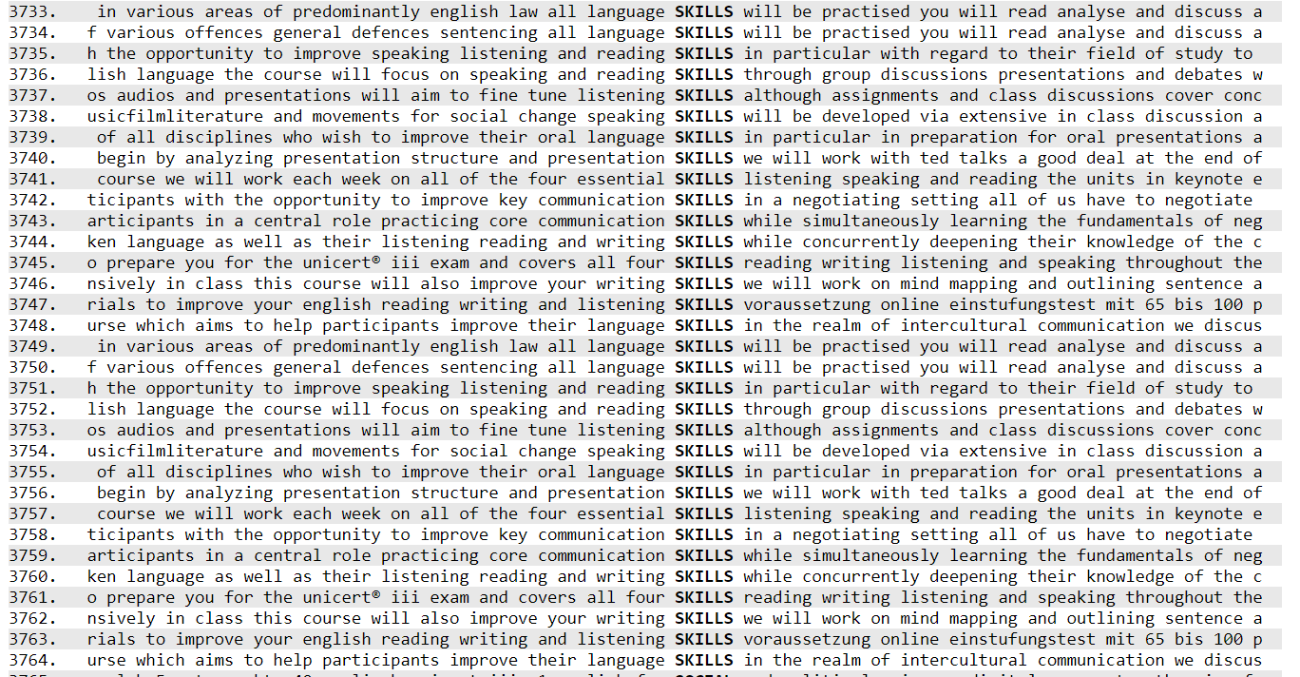

Top of Form

Bottom of Form

1. I chose C1 because many students need some kind of ‘proof of proficiency’ at C1 to progress to Masters study; indeed, one of the Language Centre’s main purposes is to provide this proof.