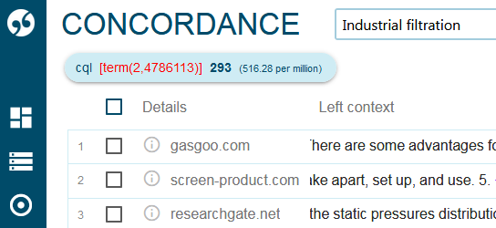

Ticking the URL box allowed the full website information to be exported:

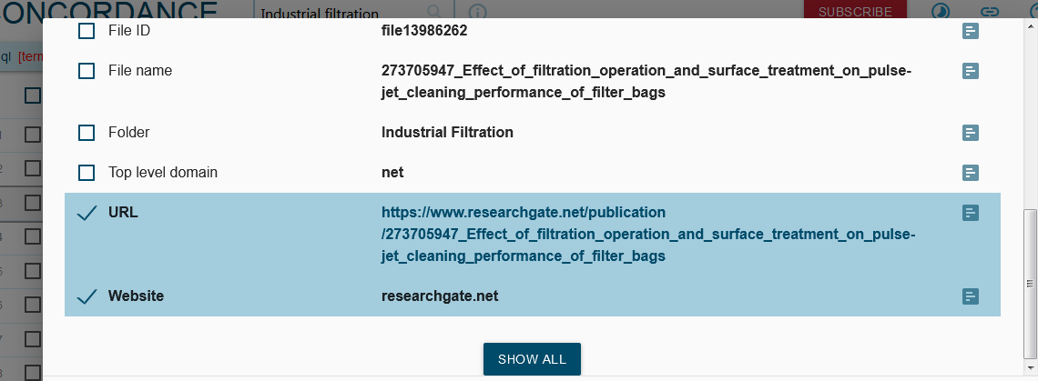

As so:

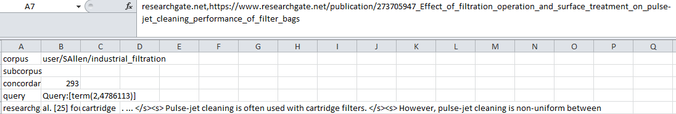

How to get the above info for the whole corpus?

