Unit 7: More about the learner

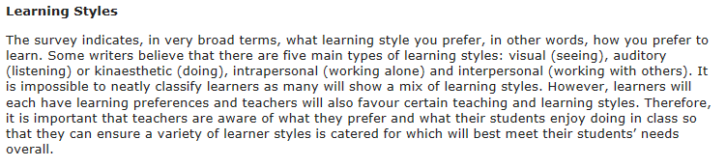

Unit 8: Checking understanding

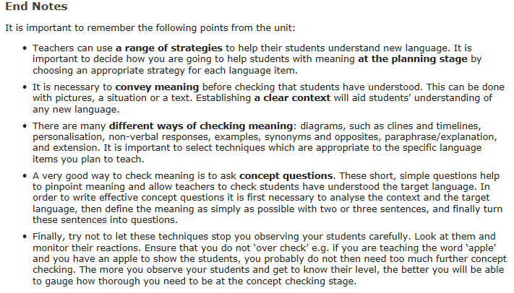

Unit 14: Correction

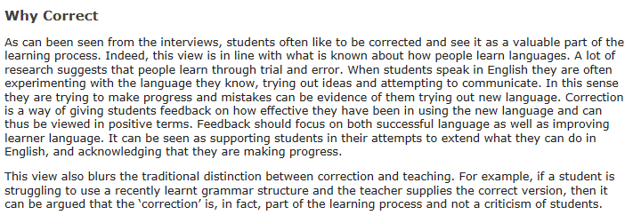

Unit 16: Grammar

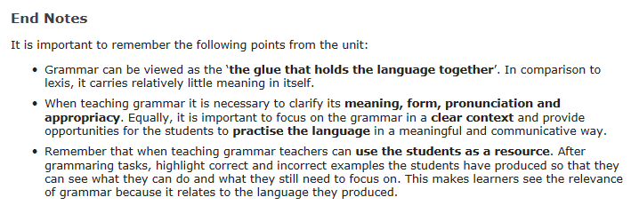

Unit 23: Beyond the Coursebook

