TBLT Forum task session 6 – Speakout 2nd Edition Extract from a Job Interview

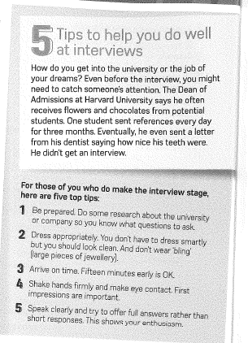 | 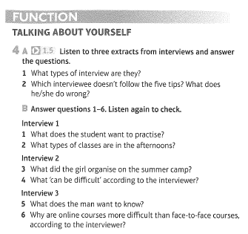
Speakout Intermediate p.164 audio script (Interview 2 from Ex 4a)

I: There are a couple of things I’d like to ask about, Jade. Your CV says you have some experience of looking after children?
A: Yes, I was a tutor on a summer camp last year.
I: Can I ask you about that? What types of things did you do?
A: Um, well, I organised games.
I: Games for?
A: The children.
I: OK. And what age were the children?
A: Um.. seven to ten.
I: OK. And you enjoyed it?
A: Yes.
I: What aspect, what part did you enjoy, would you say?
A: I suppose I’d have to say I liked the games the best.
I: And any problems?
A: Um, no.
I: What about the different ages? We often find that different ages together can be difficult.
A: It depends. In my opinion, you can usually get the older children to help the younger ones.

